IAT- Project Assessment
Applied Data Analytics

Sabrina Alam Tithi
Student ID - 881939641

Task 1.1 Attribute types Exploration
Attribute | Attribute Type | Justification
ID | Nominal (Identifier) | Used only to uniquely identify each passenger
Gender | Nominal | Categories (Male, Female) have no natural order.
Custom Type | Nominal | Categorical
Age | Numeric (Ratio) | Has a true zero point
Type of Travel | Nominal | Categorical has no inherent order
Class | Nominal | Categories with no order
Flight Distance | Numeric (Ratio) | Measured in distance units with a true zero point
Inflight WiFi Service | Ordinal | Levels of satisfaction show order
Departure/ Arrival Time Convenience | Ordinal | Levels of satisfaction show order
Ease of Online Booking | Ordinal | Service ratings follow an ordered scale.
Gate Location | Ordinal | Level of satisfaction show order
Food and Drink | Ordinal | Levels of satisfaction show order
Online Boarding | Ordinal | Levels of satisfaction show order
Seat Comfort | Ordinal | Levels of satisfaction show order
Infight Entertainment | Ordinal | Levels of satisfaction show order
On-board Service | Ordinal | Levels of satisfaction show order
Leg Room Service | Ordinal | Levels of satisfaction show order
Baggage Handling | Ordinal | Levels of satisfaction show order
Check-in Service | Ordinal | Levels of satisfaction show order
Inflight Service | Ordinal | Levels of satisfaction show order
Cleanliness | Ordinal | Levels of satisfaction show order
Departure Delay in Minutes | Numeric (Ratio) | Measured numerically in minutes with a meaningful zero value.
Arrival Delay in Minutes | Numeric (Ratio) | Measured numerically in minutes with a meaningful zero value.
Satisfaction | Nominal | Categories (Satisfied, Neutral/Dissatisfied) are labels rather than ranked values.
Task 1.2 Statistical Types of Attributes

Attribute | Mean | Standard Deviation | Variance | Median
Age | 39.426 | 15.132 | 228.968 | 40
Flight Distance | 1190.922 | 997.512 | 995029.624 | 844
Inflight WiFi service | 2.729 | 1.329 | 1.767 | 3
Seat comfort | 3.441 | 1.319 | 1.741 | 4
Online boarding | 3.253 | 1.351 | 1.824 | 3
Cleanliness | 3.286 | 1.314 | 1.727 | 3
Departure Delay in Minutes | 14.714 | 38.071 | 1449.411 | 0
Arrival Delay in Minutes | 15.094 | 38349 | 1470.641 | 0

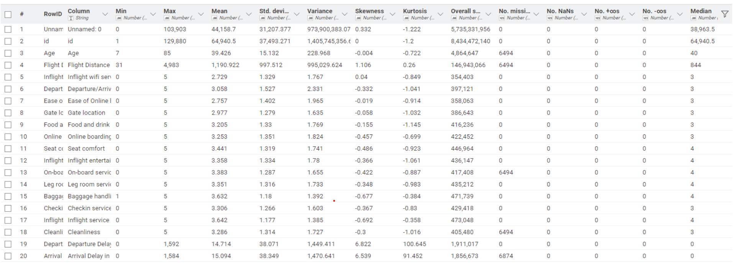
Figure 1 Statistical Table

Histogram Age: The age distribution shows that most passengers are adults, mainly between 25 and 60 years old, with the highest number around the 40–45 age range.

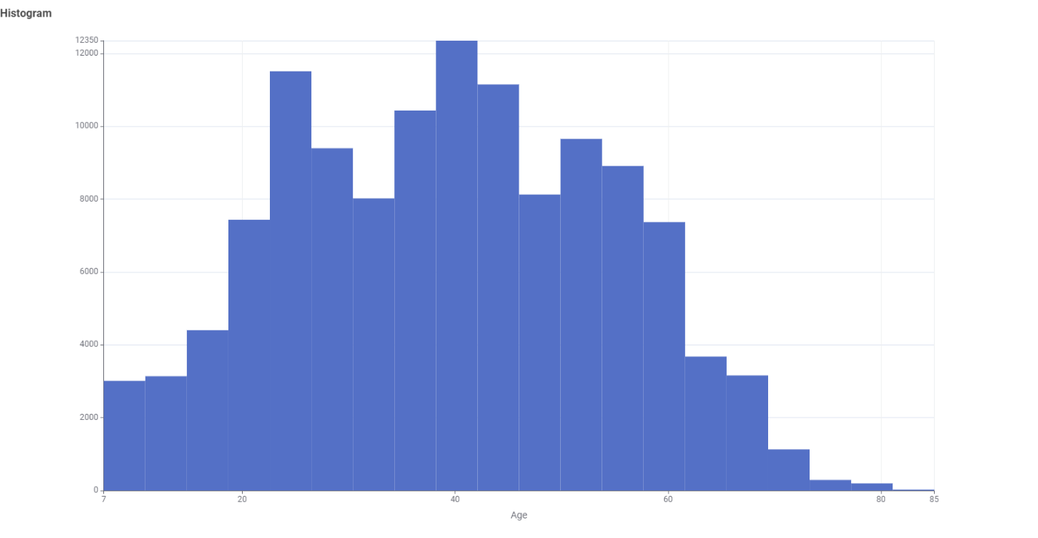
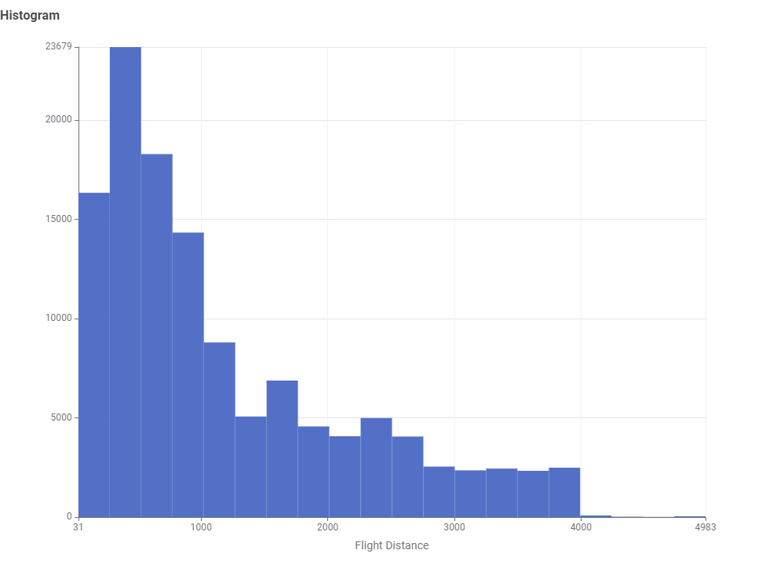
Flight Distance: The flight distance distribution is right-skewed, showing that most passengers travelled shorter distances, while only a small number travelled very long distances.

Inflight WiFi Service: Most passengers rated the inflight WiFi service between 2 and 4, with ratings 2 and 3 being the most common.

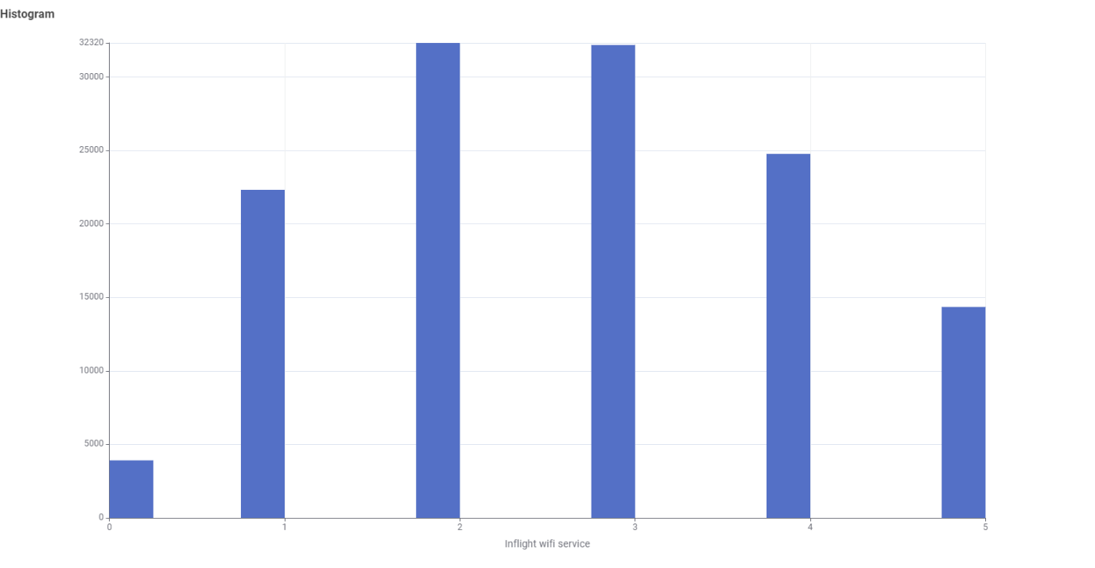

Seat Comfort: Most passengers gave high seat comfort ratings, with 4 and 5 being the most common scores.
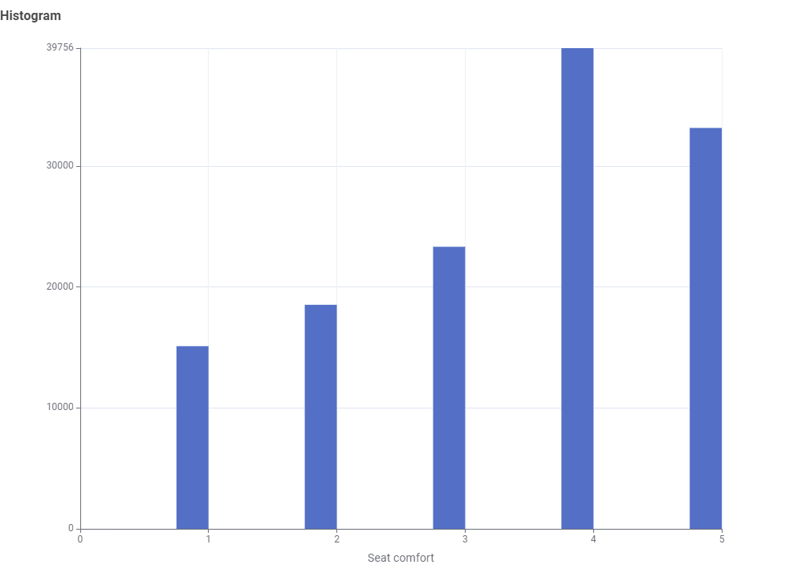
Pie Chart
Gender: The gender distribution is almost balanced, with slightly more female passengers than male passengers.
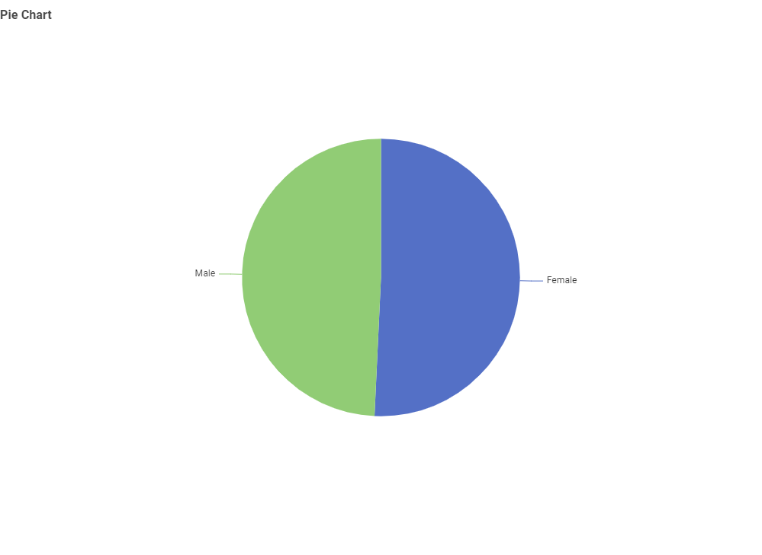
Travel Type: Most passengers travelled for business travel, while a smaller portion travelled for personal travel. 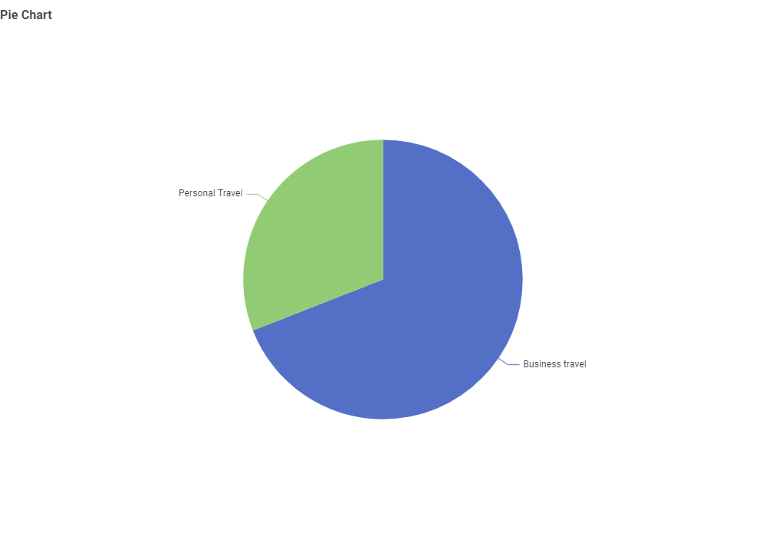

Customer type: The customer type distribution is almost evenly split between Loyal Customers and disloyal Customers.
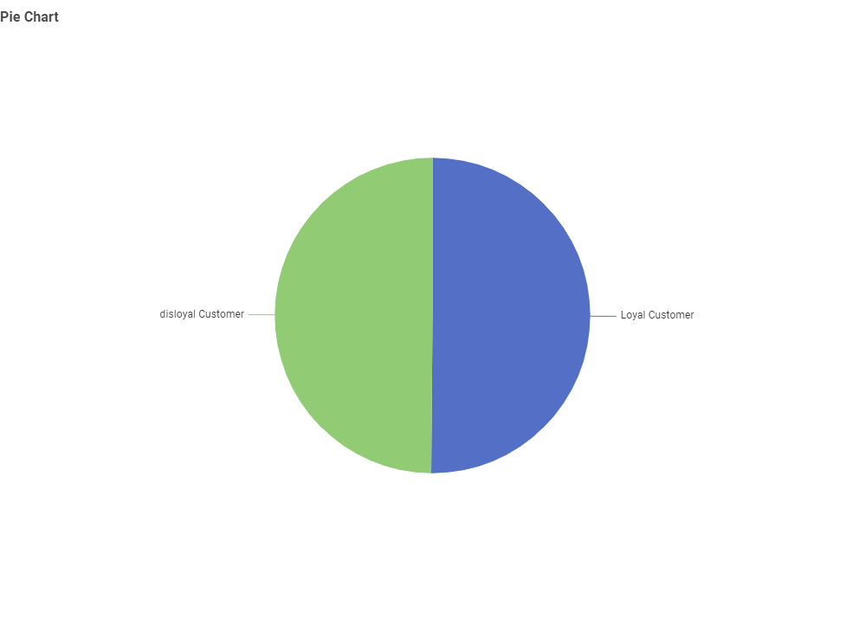
Satisfaction: More passengers were neutral or dissatisfied than satisfied, showing that overall passenger satisfaction needs improvement.
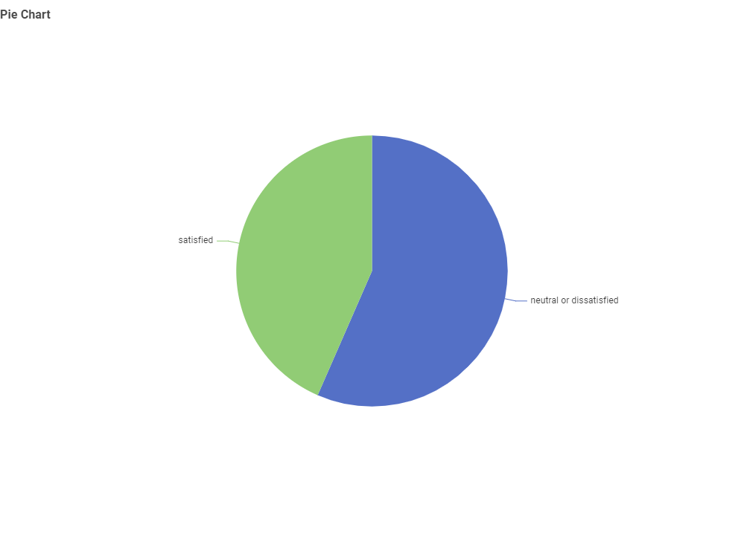

Task 1.3 Outlier Exploration
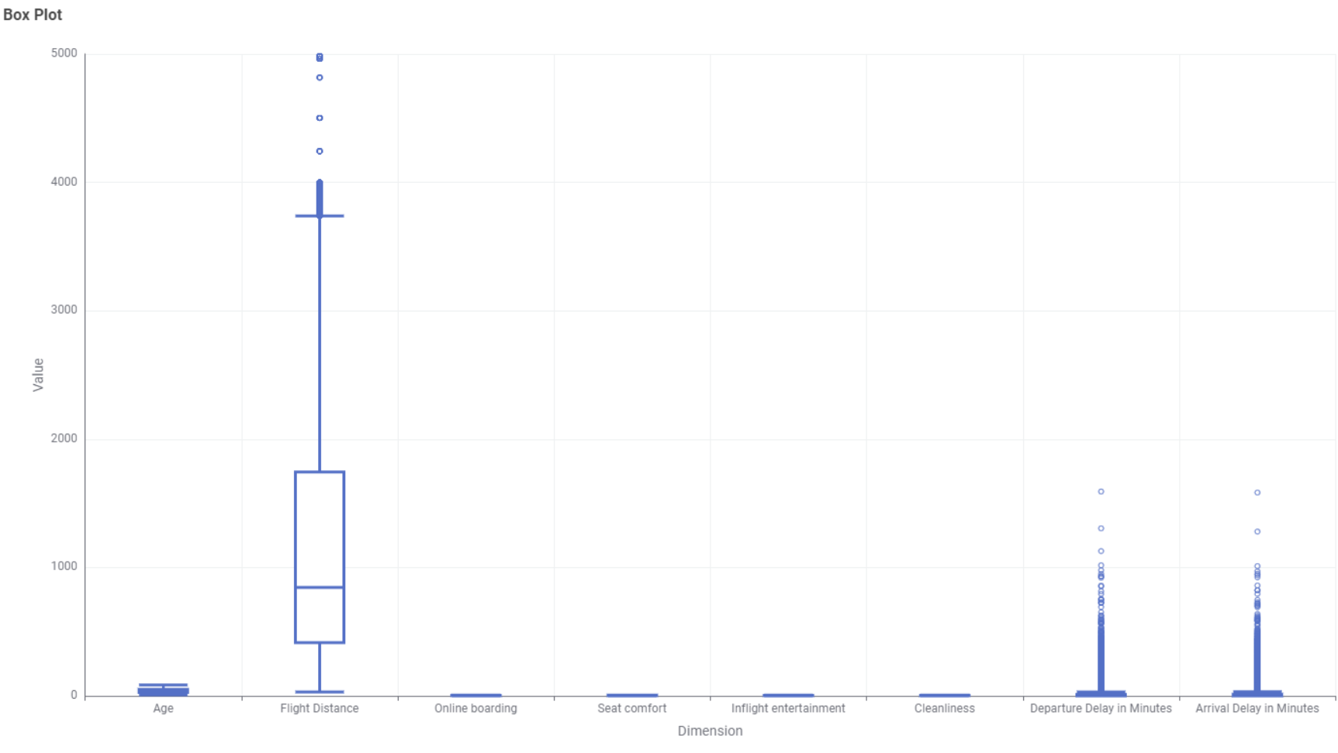

As box plots work best for numerical values these columns have been chosen for analysis.

Flight Distance
The Flight Distance box plot shows several high-value outliers that represent very long-distance flights.
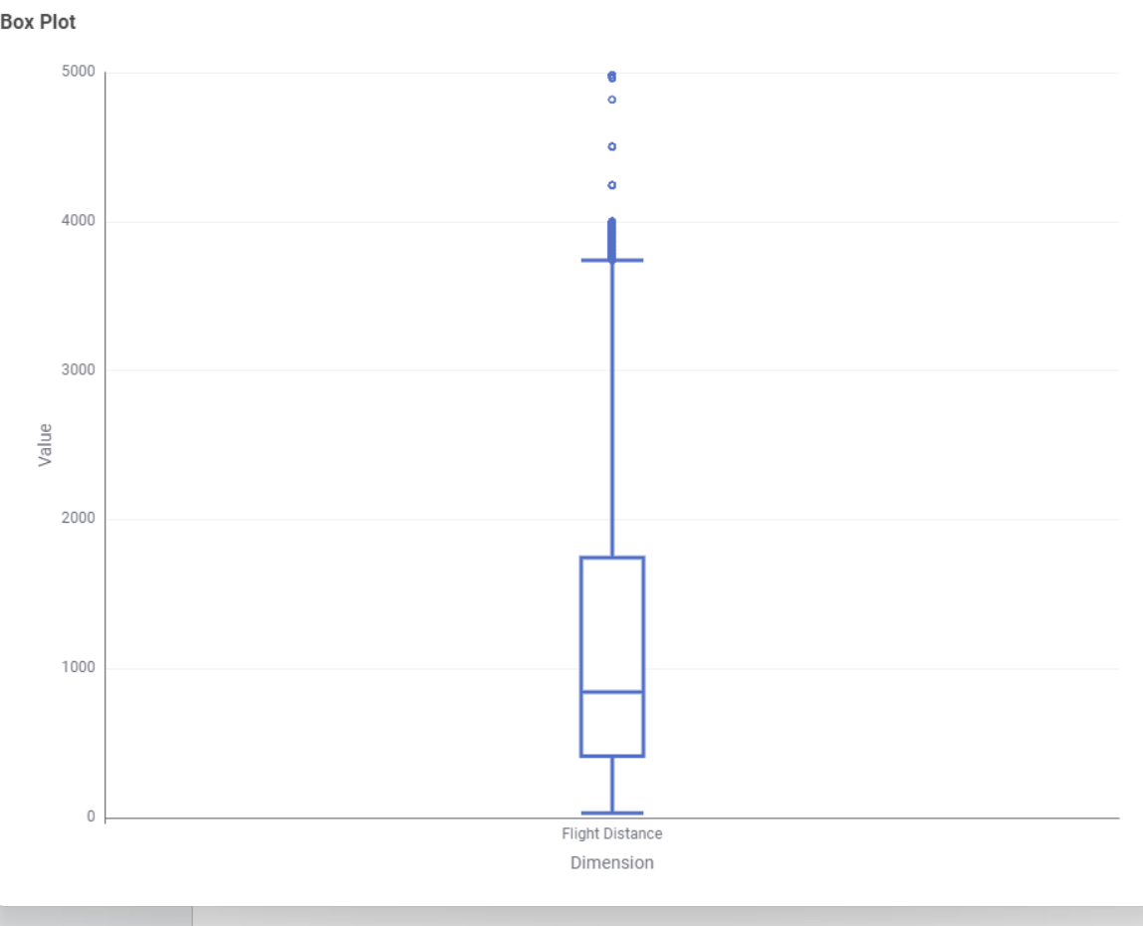

Departure Delay in minutes
Most flights have small delays, but some flights experienced very large delays that is why outliers are found here.
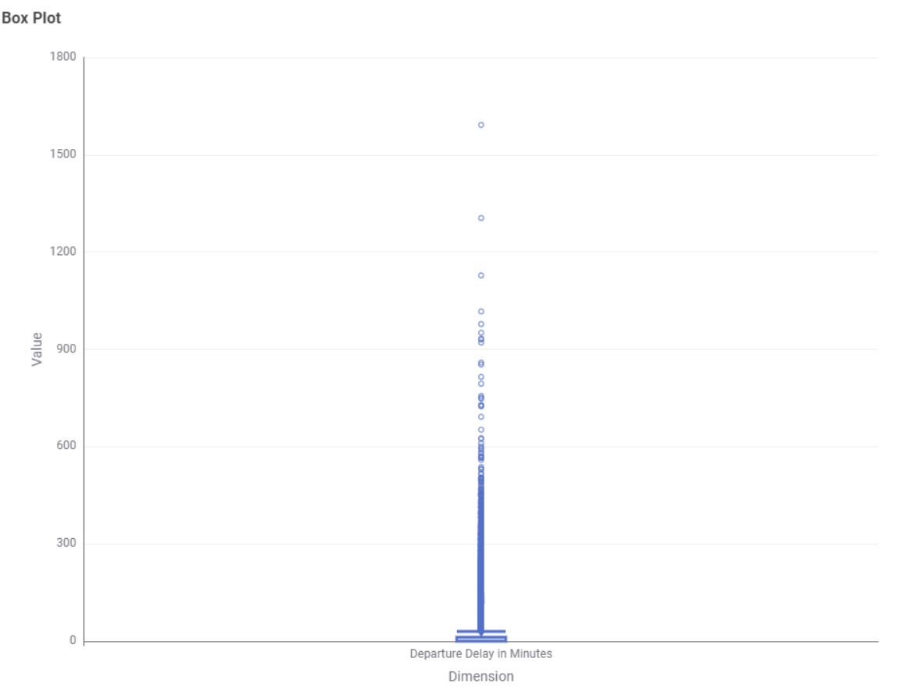

Arrival Delay in minutes
The arrival delay data contains several extreme outliers, showing that a small number of flights arrived much later than normal.
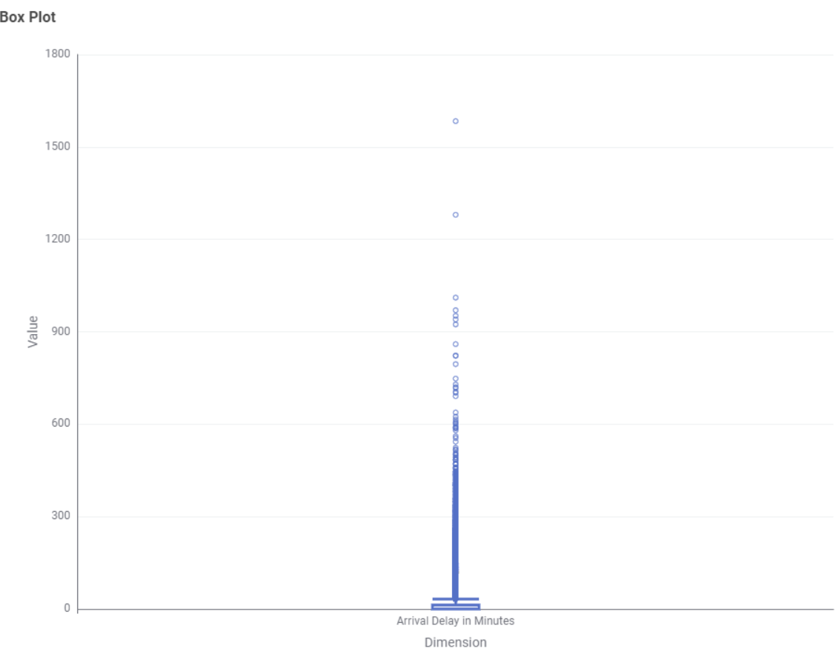
Task 1.4:
Correlation of Departure Delay in minutes and Arrival Delay in minutes

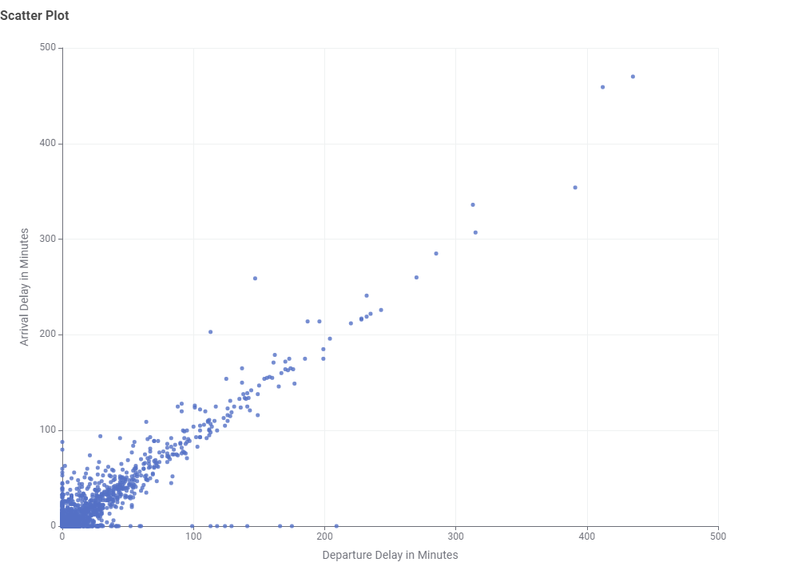

Departure Delay vs Arrival Delay
The scatter plot indicates a strong positive linear relationship between departure delay and arrival delay.
The correlation coefficient is approximately 0.965, that is very close to +1.
This shows that flights departing late tend to arrive late as well. The points in the scatter plot shows an upward trend, that confirms the strong relation between the two variables.

Correlation 2:
Between Online boarding vs Average satisfaction
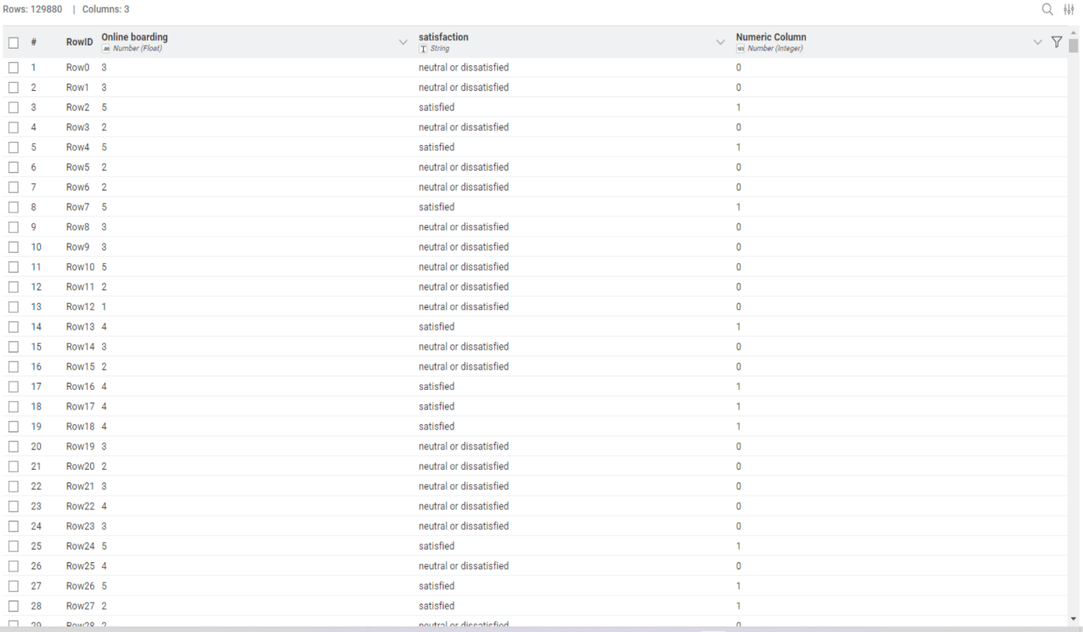
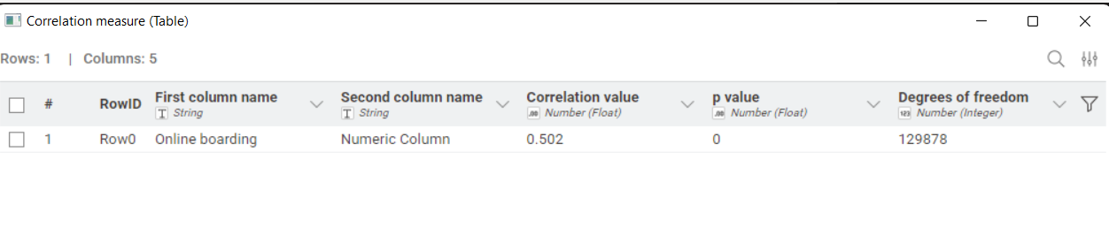
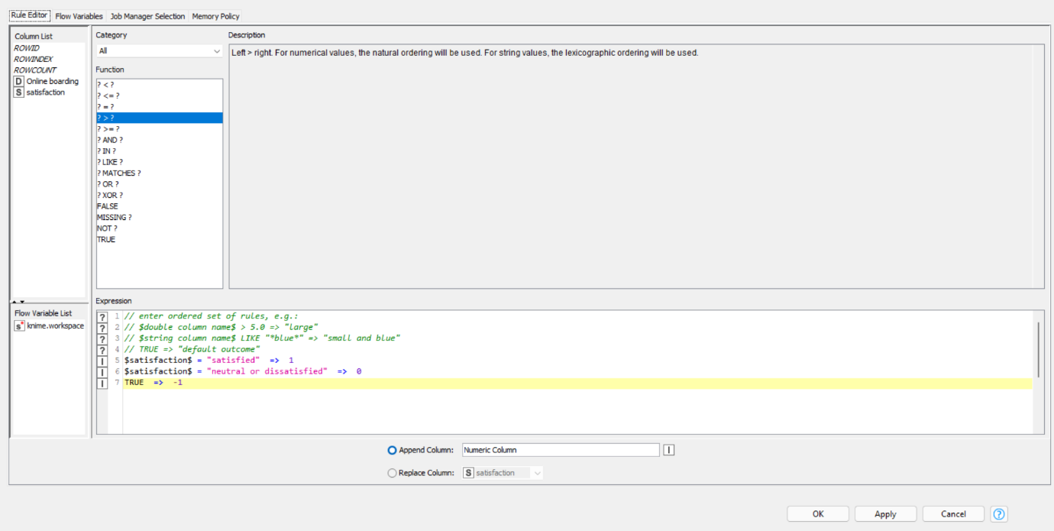
Figure 2: Configuration of Satisfaction

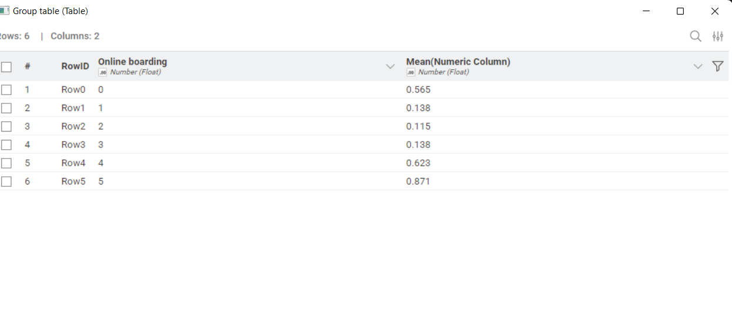

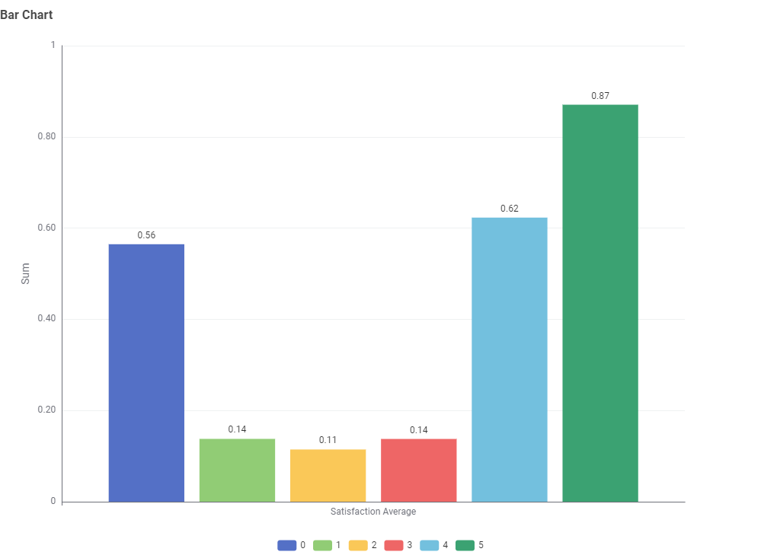

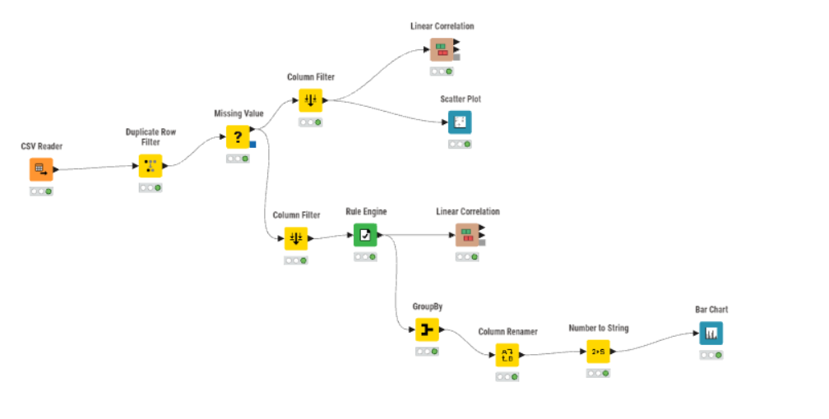
Figure 3: Knime workflow of Task 1.4

Interpretation:
For this relationship, Online boarding was compared with passenger satisfaction. As satisfaction is a categorical attribute, it was temporarily recoded into numeric form using the Rule Engine node. The value "satisfied" is recoded as 1 and "neutral or dissatisfied" is recoded as 0.
The GroupBy node is used to group passengers by their Online boarding rating. For each rating, the mean of satisfaction numeric was calculated. This mean value presents the average satisfaction level for each online boarding rating.
A bar chart has been created using Online boarding as the X-axis and Average Satisfaction as the Y-axis. The chart presents that the passengers with higher online boarding ratings had higher average satisfaction. This shows positive relationship between the online boarding experience and passenger satisfaction.

Task 2.1
Binning Departure Delay in Minutes
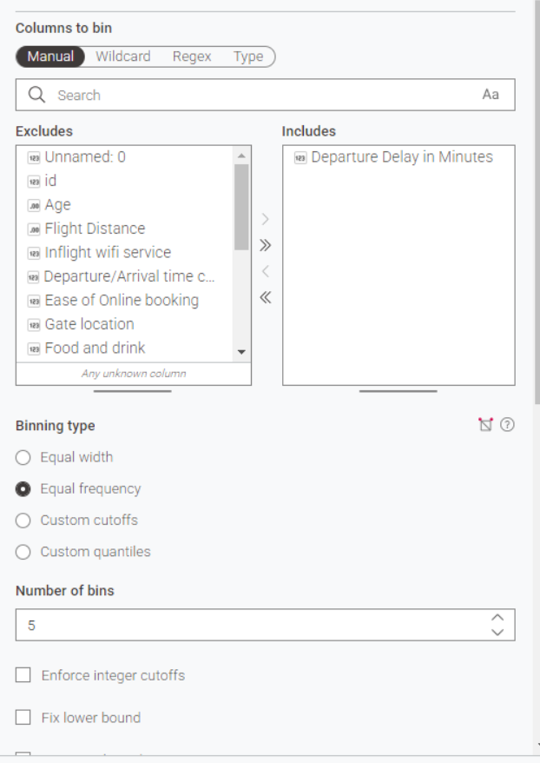
This is the configuration of Departure Delay in Minutes.

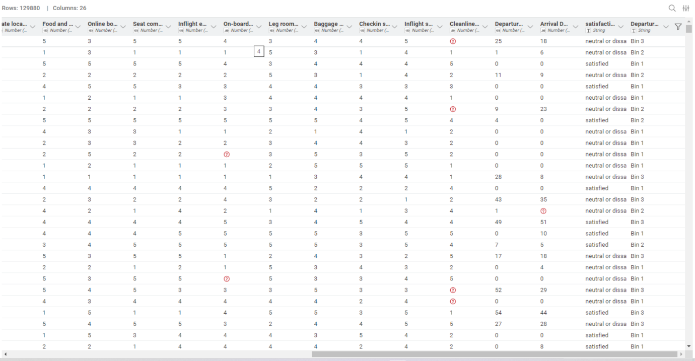
Figure 4: Table after binning Departure Delay in minutes

Interpretation:
The Departure Delay in Minutes attribute was grouped using equi-depth binning. Five bins were selected because this gives enough detail while keeping the results simple to interpret. Equi-depth binning was chosen because the departure delay values are not evenly distributed, with many flights having no delay and a smaller number having very large delays. This technique helps create more balanced than equi-width binning.

2.2. Discretise Age into categories 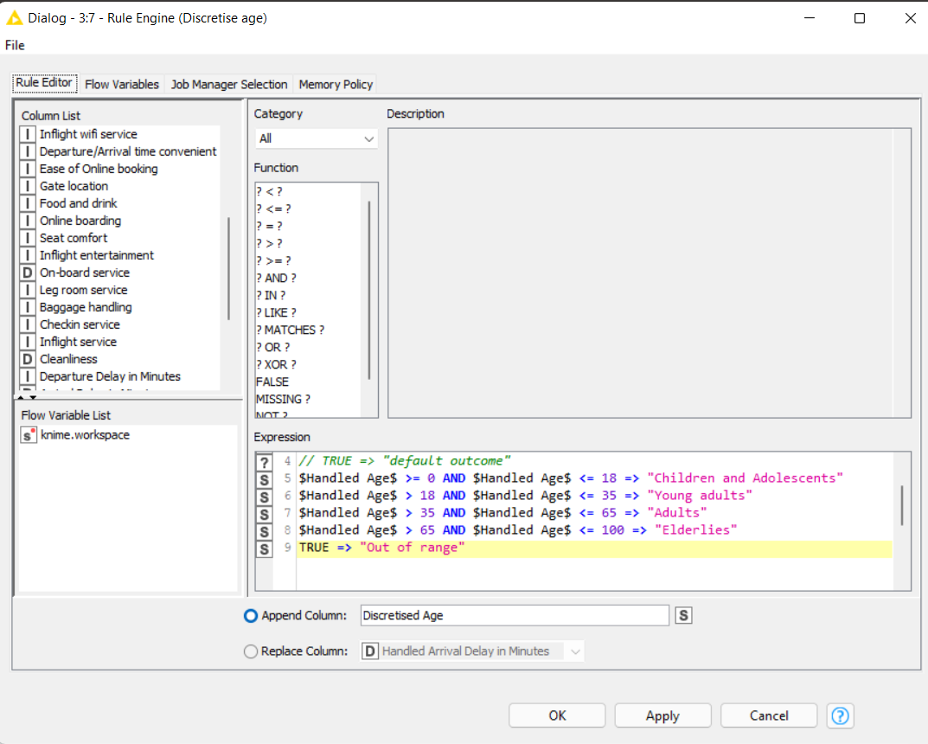

This is the configuration of Handled age after dealing with the missing values.

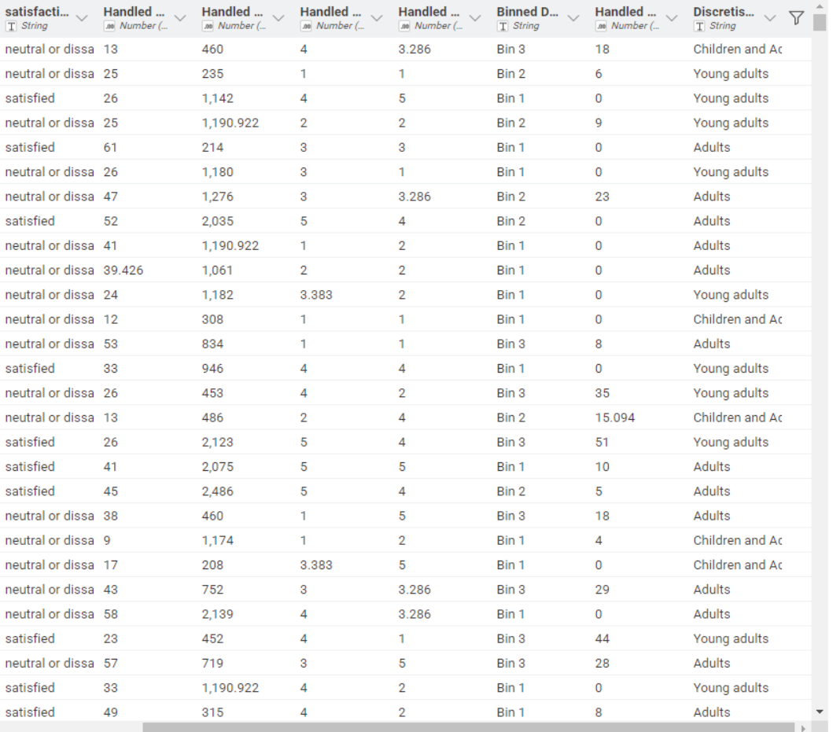
Figure 5: Table after adding Discretised Age column

Interpretation:
The Age attribute had missing values, so missing value handling was performed before age discretisation. Since, Age is a numeric attribute, which means replacement was used to fill missing Age values. The handled values are stored in a new column called Handled Age as the original Age column was kept unchanged.
After handling the missing values, the Handled Age column was discretised into four categories using the Rule Engine node. Ages below 18 were classified as Children and Adolescents, ages from 18 to below 35 were classified as Young adults, ages from 35 to below 65 were classified as Adults, and ages from 65 to 100 were classified as Elderlies. The resulting categories were stored in a new column called Discretised Age.

Task 2.3 missing value handling
The columns that have missing values are Age, Flight distance, Onboard service, Cleanliness, Arrival Delay in minutes.
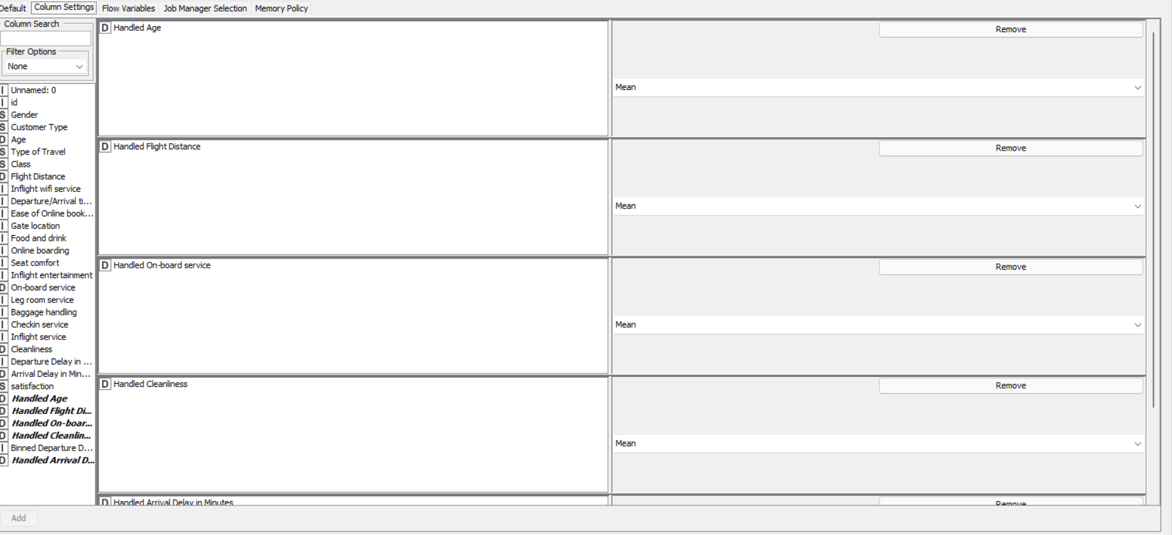
The missing values replaced by mean value of the particular columns using the missing value node. New columns were named Handled age, Handled Flight distance, handled Onboard service, Handled Cleanliness, Handled Arrival delay in minutes.
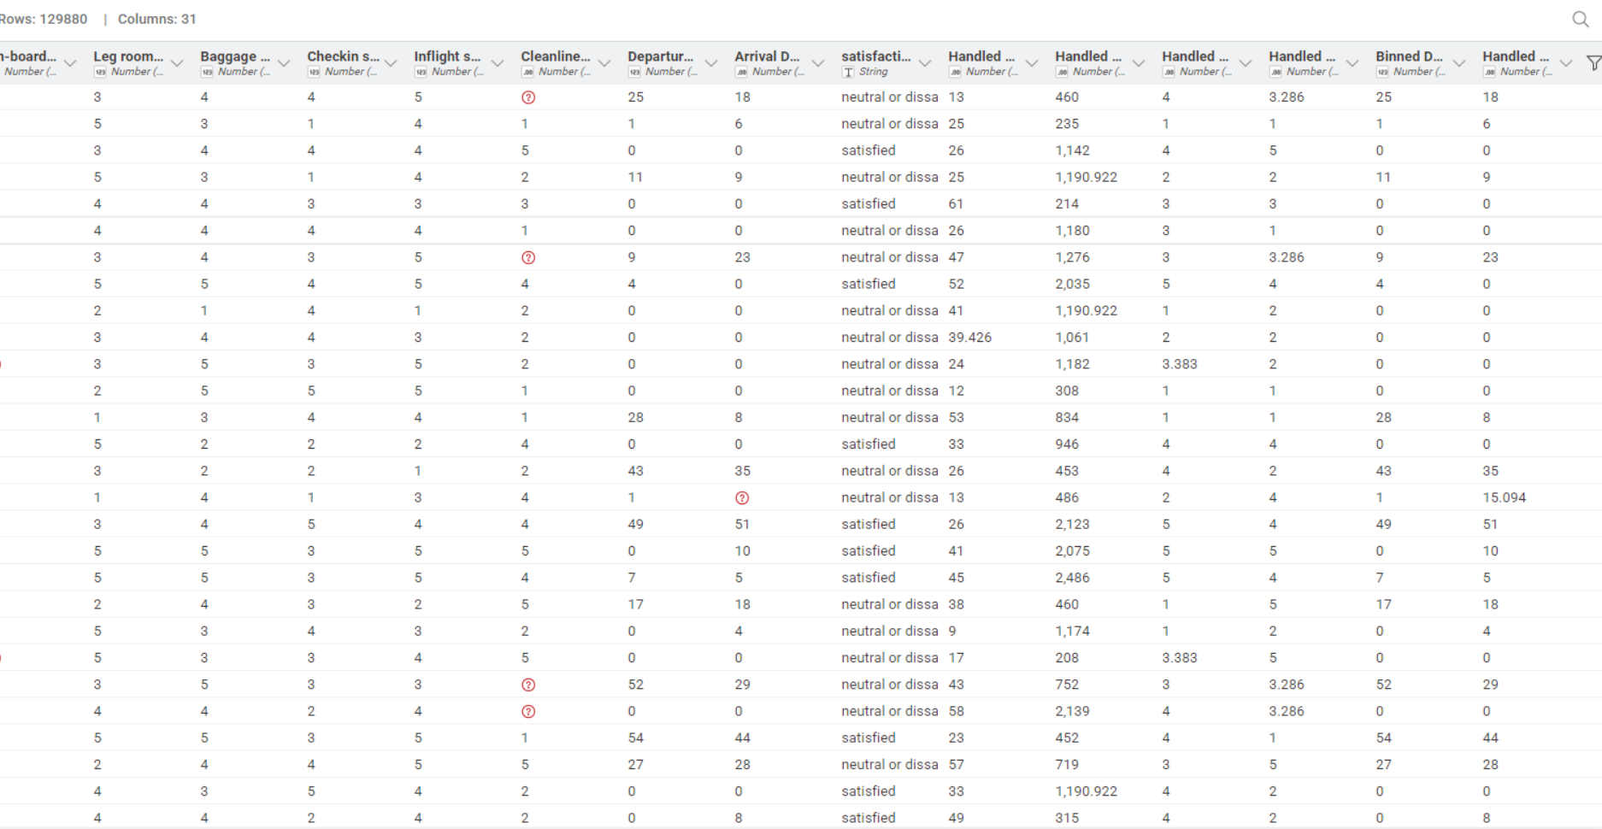

Task 2.4
Normalise all the continuous/numerical variables
The configuration of the normalizer is given below:

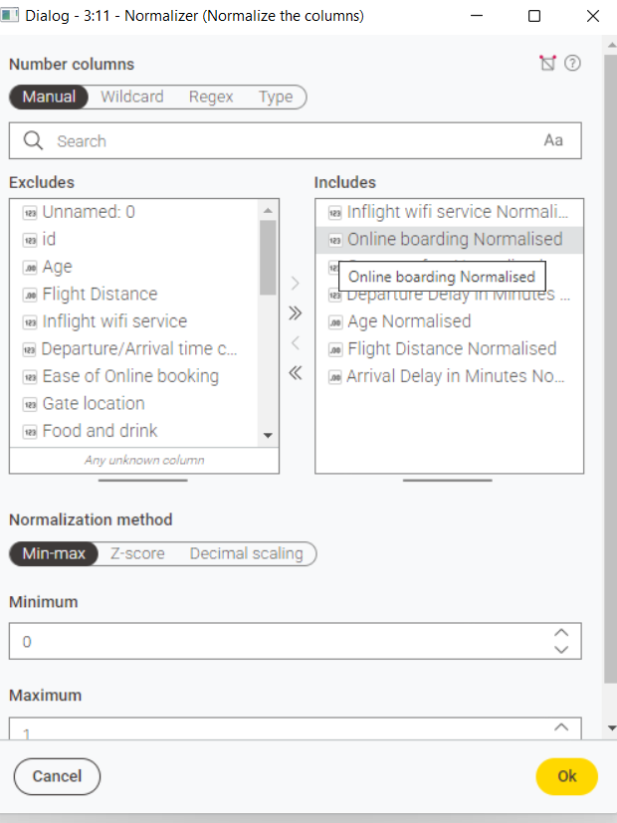

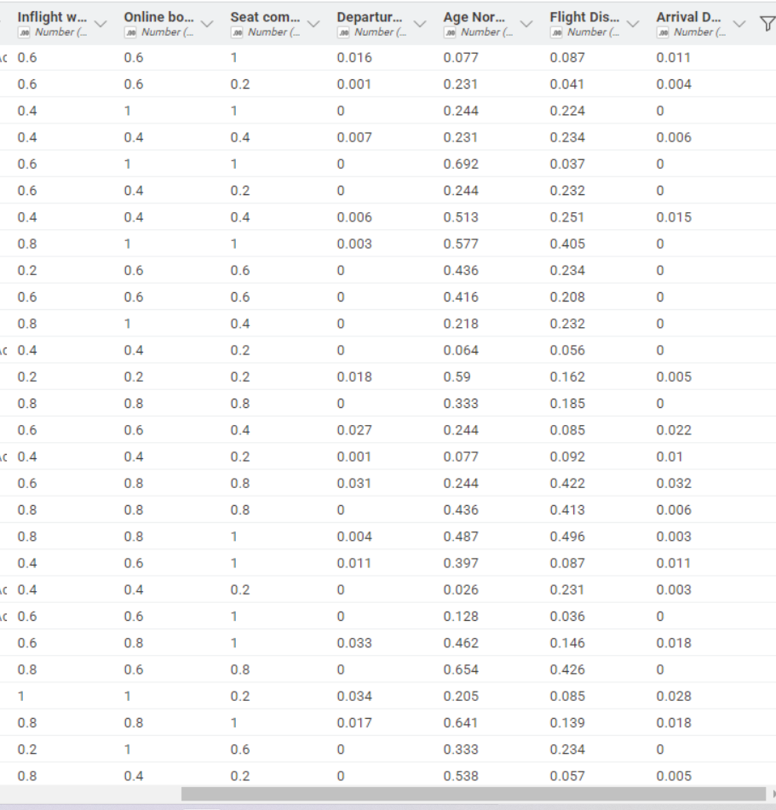
Figure 6: Table with Normalised values
For Task 2.4, I applied min-max normalisation to the continuous numerical variables. This technique transforms each value into a standard range between 0.0 and 1.0. I used the formula (x - minimum) / (maximum - minimum), where x is the original value.
The continuous variables normalised were Age, Flight Distance, Departure Delay in Minutes, and Arrival Delay in Minutes. Identifier fields for instance id and Unnamed: 0 were excluded as they do not represent meaningful measurable attributes.
The normalised results were added as separate columns in the Excel workbook beside the corresponding original variables.

The final Knime workflow for Data Modelling is:

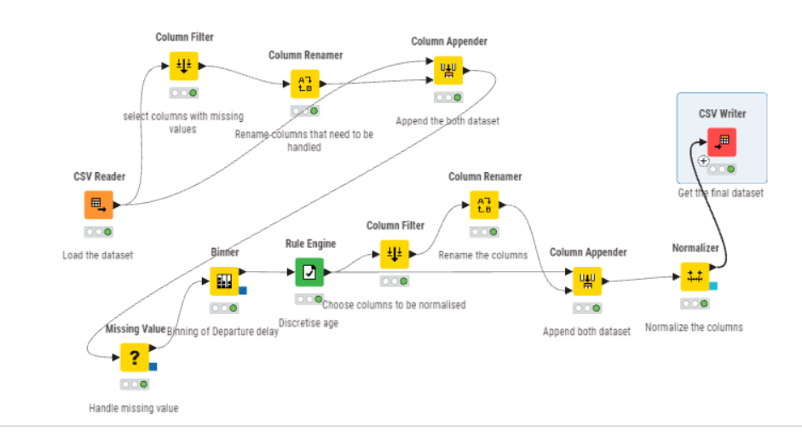

Task 3:
Data Modelling Method
For Task 3, I created a prediction model to predict the satisfaction attribute. This is a classification task because the target column contains two categories: satisfied and neutral or dissatisfied.
Classification method
I used a Decision Tree classification model. This method was selected because it is suitable for categorical prediction problems and is easy to interpret. The model learns rules from passenger attributes such as age, type of travel, class, flight distance, online boarding, seat comfort, inflight service, cleanliness, and delay time.
The final Knime workflow for this task is:
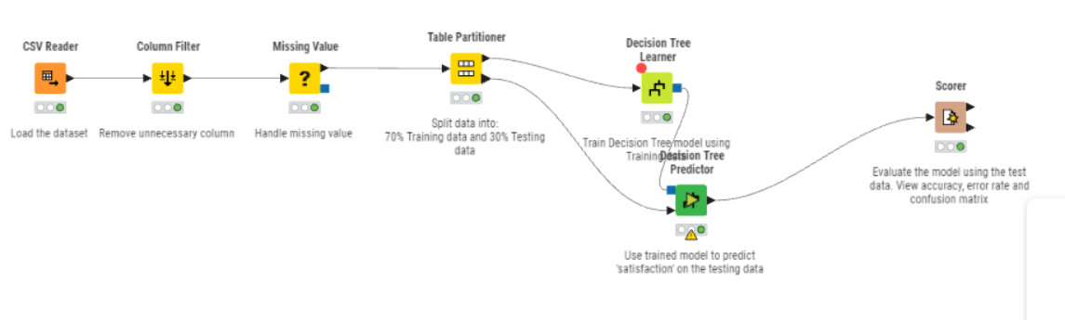
Data preparation
Before building the model, I removed unnecessary identifier columns such as Unnamed: 0 and id. Missing numerical values were replaced using the median value. Mean replacement was used because it is less affected by extreme values, especially for delay-related columns.
Train/test split
The dataset was split into 70% training data and 30% testing data using the Partitioning node in KNIME. The training data was used to build the model, while the testing data was used to evaluate how well the model performs on unseen data. Stratified sampling was applied using the satisfaction column so that both satisfaction classes were fairly represented in both datasets.

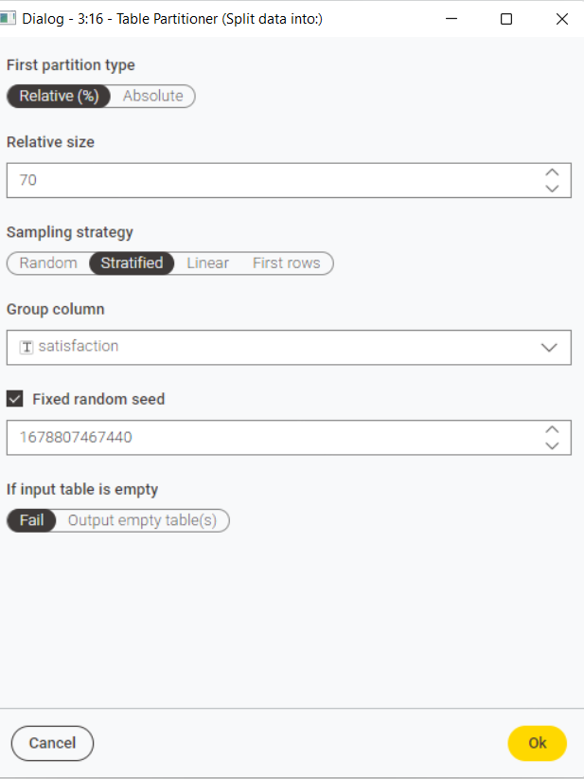
Figure 7: configuration of Table Partitioner.

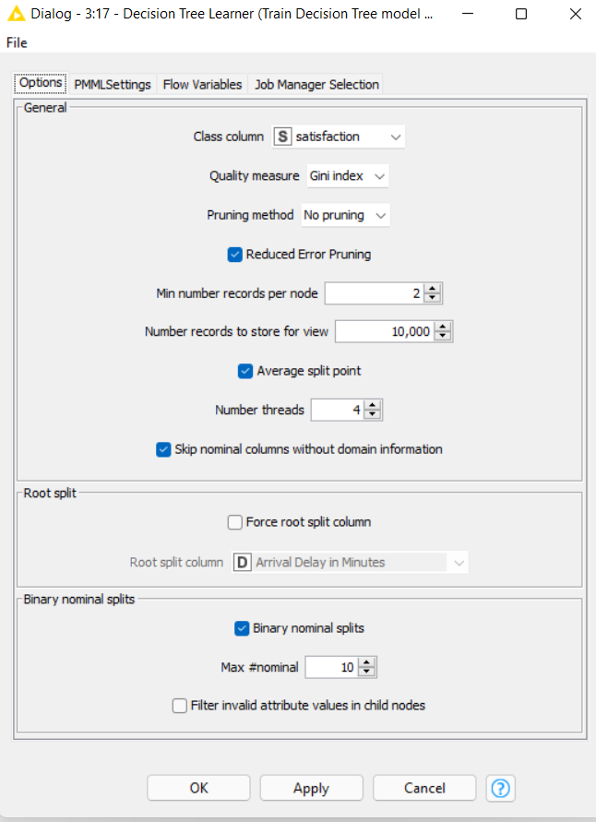
Figure 8:Configuration of Decision Tree Learner

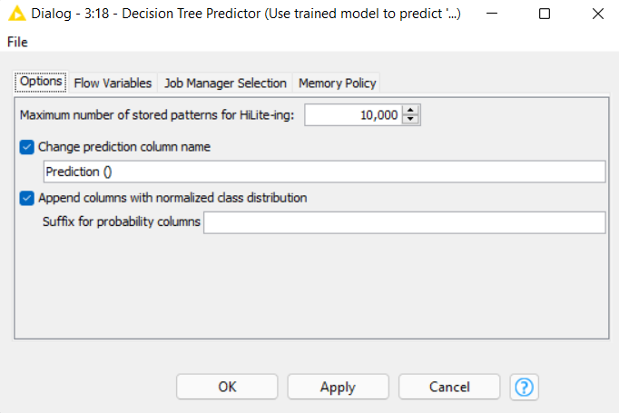
Figure 9: Configuration of Decision Tree Predictor

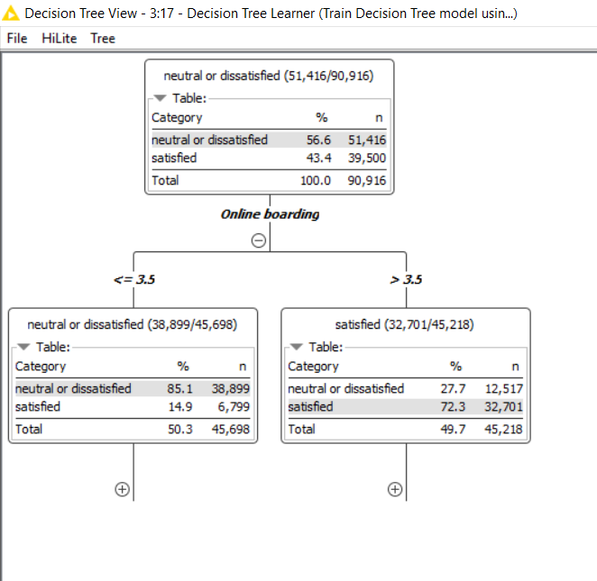
Figure 10: Open view of Decision tree Learner
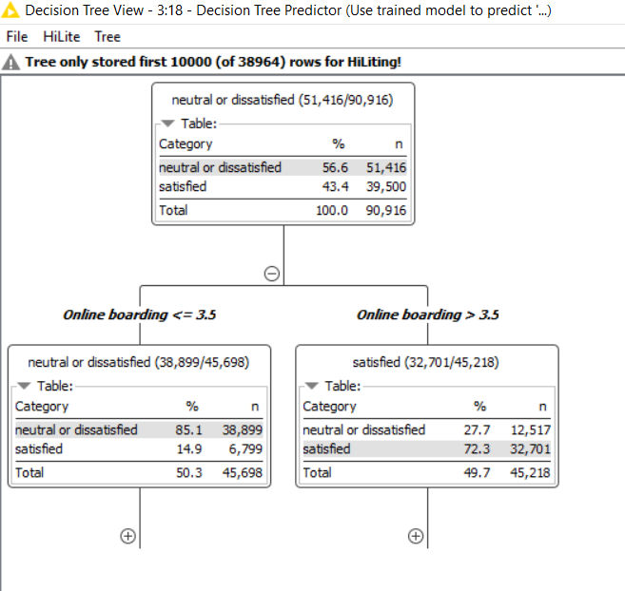
Figure 11: Open view of Decision Tree Predictor

Evaluation:
The model was evaluated using the Scorer node. The main evaluation measures were accuracy and error rate. Accuracy shows the percentage of correct predictions, while error rate shows the percentage of incorrect predictions.
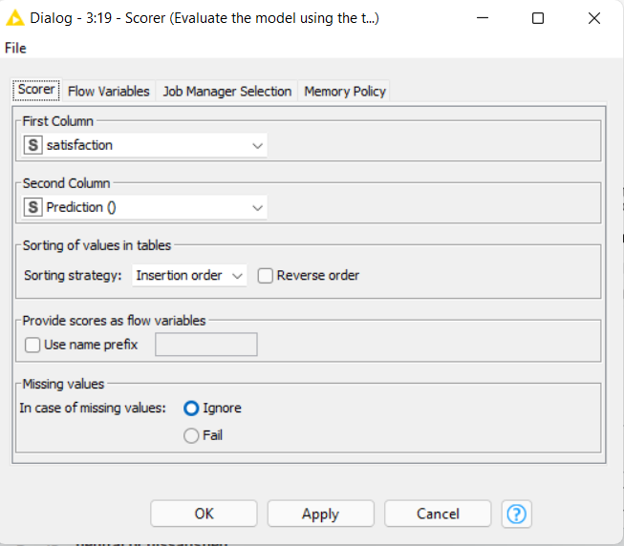
Figure 12: Configuration of Scorer
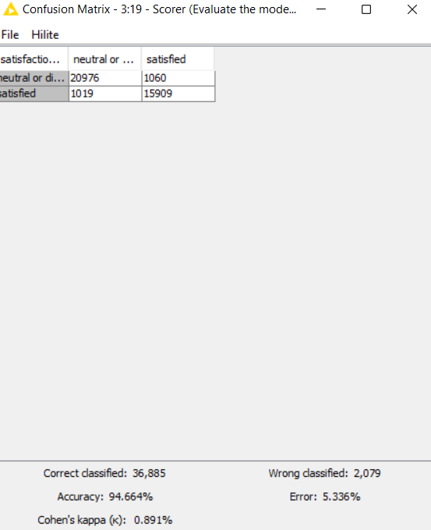
Figure 13: Confusion Matrix

Interpretation:
The classification model predicts whether a passenger is satisfied or neutral/dissatisfied based on service, travel, and delay-related attributes. A high accuracy score indicates that the model has learned useful patterns from the passenger data. The confusion matrix shows how many satisfied and neutral/dissatisfied passengers were correctly or incorrectly classified.

Task 4 Summary:
This analysis was done to understand what affects airline passenger satisfaction. The dataset consists of information about passengers, their travel details, service ratings, flight delays, and their final satisfaction result. The main column used for the analysis was satisfaction, which had two outcomes: satisfied and neutral or dissatisfied.
From the data exploration, it was found that more passengers were neutral or dissatisfied than satisfied. This means the airline needs to improve some parts of the passenger experience. Some columns seemed to have a stronger link with satisfaction, such as online boarding, seat comfort, inflight entertainment, cleanliness, on-board service, and travel class. This shows that comfort and service quality can affect how passengers feel about their flight.
The analysis has also represented that departure delay and arrival delay were closely related. Flights that left late usually arrived late as well. The delay columns also had many outliers, especially flights with very long delays. These values should not be removed straight away because they may be real delay cases. They are important because long delays can affect passenger satisfaction.
During data preprocessing, missing values were found in columns such as Age, Flight Distance, On-board service, Cleanliness, and Arrival Delay in Minutes. These missing values were handled before building the model. The Age column was grouped into four categories: Children and Adolescents, Young adults, Adults, and Elderlies. To understand the delay values easily departure delay in minutes column was grouped into bins. The numerical columns were normalised using min-max normalisation, which changed the values into a range between 0.0 and 1.0.
For data modelling, a Decision Tree classification model was used to predict passenger satisfaction. The data was split into 70% training data and 30% testing data. Stratified sampling was used based on the satisfaction column, so both satisfaction groups were included fairly in the training and testing data.
The Decision Tree model performed well. It correctly classified 36,885 records and incorrectly classified 2,079 records. The model achieved an accuracy of 94.664% and an error rate of 5.336%. The Cohen’s Kappa value was 0.891, which means the model predictions were strongly matched with the actual satisfaction results. The confusion matrix also showed that the model predicted both satisfied and neutral or dissatisfied passengers well.
One important result from the Decision Tree was that online boarding was the first main split in the model. This means online boarding was one of the most important factors for predicting satisfaction. Passengers who gave online boarding a score above 3.5 were more likely to be predicted as satisfied. Passengers with lower online boarding scores were more likely to be predicted as neutral or dissatisfied.
To sum up, the analysis shows that passenger satisfaction is mainly affected by online boarding, travel class, service quality, and flight delays. The airline should focus on improving the online boarding process, Economy and Eco Plus passenger experience, seat comfort, cleanliness, and delay management. The airline should also improve data quality by handling missing values properly and checking unusual values before future analysis. These steps can help the airline better understand passenger needs and improve customer satisfaction.

